附件
第三届国际天然活性配体金属药物化学论坛日程表

Day 1 (December 7th, 2023)
Program / GMT +8:00
08:30-08:35 | Opening by Prof. Hong Liang (Director, The State Key Laboratory for Chemistry and Molecular Engineering of Medicinal Resources, Guangxi Normal University, China)
Session Chair:
08:40-09:10 | Prof. Jonathan L. Sessler (The University of Texas at Austin, USA)  Texas-Inspired Drug Discovery Efforts | Local Time: 18:40-19:10, Dec 6
09:10-09:40 | Prof. Wonwoo Nam (Ewha Womans University, Korea)  Biomimetic Metal-Oxygen Intermediates in Dioxygen Activation and Formation Chemistry
09:40-10:10 | Prof. Muhammad Iqbal Choudhary (University of Karachi, Pakistan)  Discovery of Novel Anti-inflammatory, and Anti-obesity Agents – Science at the Interface of Chemistry and Biology | Local Time: 06:40-07:10, Dec 7
10:10-10:30 | Coffee Time
Session Chair:
10:30-11:00 | Prof. Christian Hartinger (University of Auckland, New Zealand)  Towards an Understanding of Metal Complex–Protein Interactions
11:00-11:30 | Prof. Xiao-Da Yang (Peking University, China)  Rational Design of Anti-diabetic Vanadium Complexes
11:30-12:00 | Prof. Zhen-Feng Chen (Guangxi Normal University, China)  Metal-base Anticancer Agents Basing on New Design Strategy
12:00-15:00 | Noon Break
Session Chair:
15:00-15:30 | Prof. Wee-Han Ang (National University of Singapore, Singapore)  Combinatorial Coordination Chemistry: Engineering Ruthenium-Arene Schiff Base Complexes for Therapy
15:30-16:00 | Prof. Min Huang (Shenyang Pharmaceutical University, China)  Design, Synthesis and Anti-tumor Activity of Novel Apoptosis Inducers Targeting the Bcl-2 Protein Family
16:00-16:30 | Prof. Yang Han Liu (Guangxi Normal University, China)  Design, Synthesis, and Biological Activity Study of SIRT5 Inhibitor
16:30-16:50 | Coffee Time
Session Chair:
16:50-17:20 | Prof. Zhi-Chao Zhang (Dalian University of Technology, China)  Development of pan-Bcl-2 PPI Inhibitors---Integration of New Targets Discovery and New Drug Screening
17:20-17:50 | Prof. Xuben Hou (Shandong University, China)  Targeting Histone Deacetylase Using Small Molecules
17:50-18:15 | Students’ presentations
Day 2 (December 8th, 2023)
Program / GMT +8:00
Session Chair:
08:30-09:00 | Prof. Nouri Neamati (University of Michigan, Ann Arbor, USA)  Targeting the Vulnerabilities of Cancer Cell Metabolism | Local Time:  19:30-20:00, Dec 7
09:00-09:30 | Prof. Mahmoud Soliman (University of Kwazulu Natal, South Africa)  Multi-catalytic Sites Inhibition of Bcl2 and Heterogenic Cooperativity Induces Structural and Conformational Changes and Enhances Drug Binding - A New Avenue Towards Cancer Therapy
09:30-10:00 | Prof. Huan-Wen Chen (Jiangxi University of Chinese Medicine)  Internal Extractive Electrospray Ionization Mass Spectrometry for Molecular Diagnosis of Thoracic Tumors
10:00-10:20 | Coffee Time
Session Chair:
10:20-10:50 | Prof. Hai-Hua Xiao (Institution of Chemistry, Chinese Academy of Science)  Polymer-based Platinum(lV) Prodrugs and Their Future Development directions
10:50-11:20 | Prof. Feng Yang (Guangxi Normal University, China)  Developing Multi-targeted Anticancer Lead Platinum Compounds Based on the Endogenous Proteins
11:20-11:50 | Prof. Atia-tul-Wahab (University of Karachi, Pakistan)  Identifying New and Novel Anti-cancer (Aromatase Inhibitors) and Anti-osteoporotic Agents- A Rational Approach
11:50-12:15 | Students’ presentations
12:15-13:00 | Closing ceremony

- Speakers
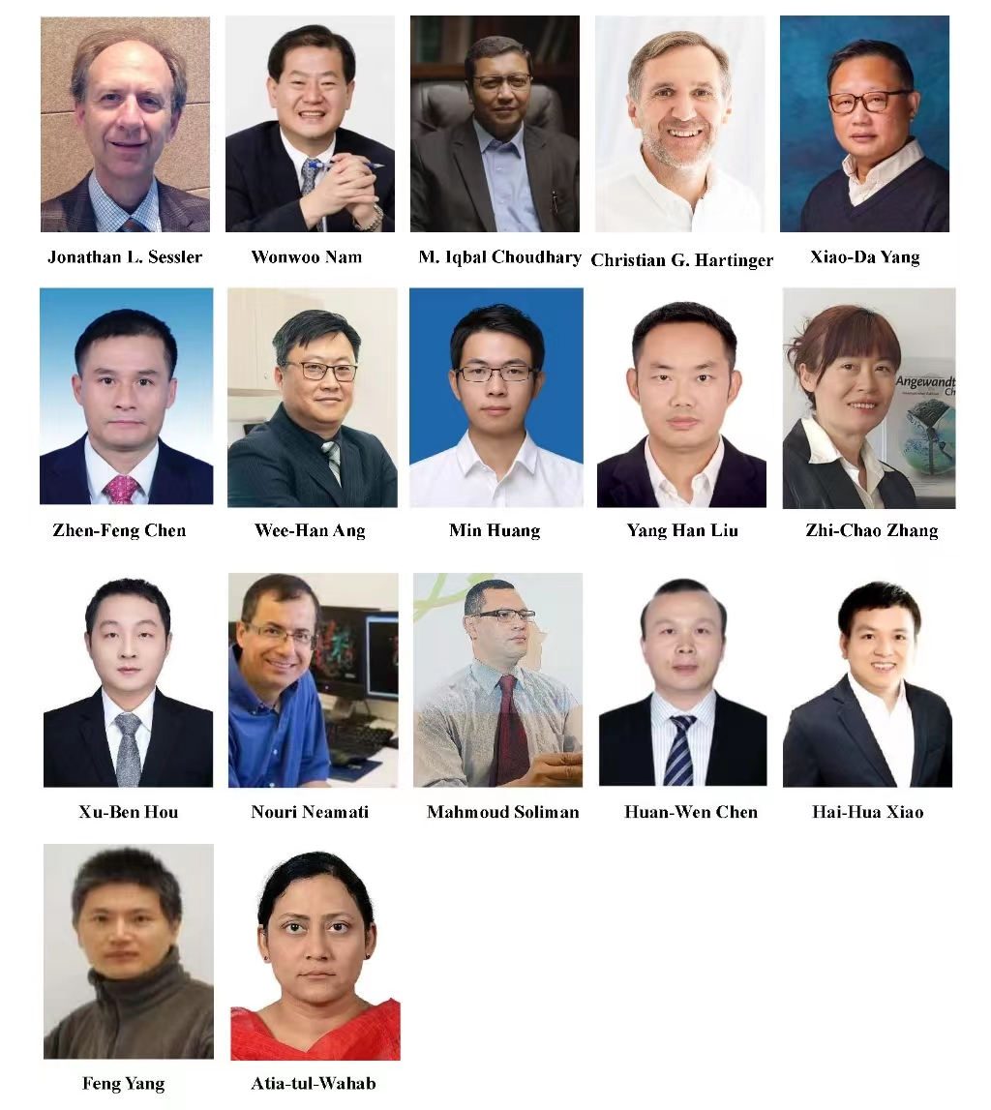

Guangxi Normal University is inviting you to a scheduled Zoom meeting.

Topic: The 3rd International Forum on Medicinal Chemistry of Natural Active Ligand Metal-based Drugs
Time: 2023.12.07-08（GMT+8）

Join Zoom Meeting
https://zoom.us/j/98002168125?pwd=VmRNb2hUZ3plKzR0K1JHS3JUUi9IQT09

Meeting ID: 980 0216 8125
Passcode: 888888

Website of conference
http://www.cmemr.gxnu.edu.cn/2023/1204/c6252a279413/page.htm

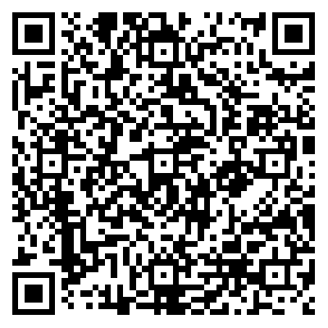
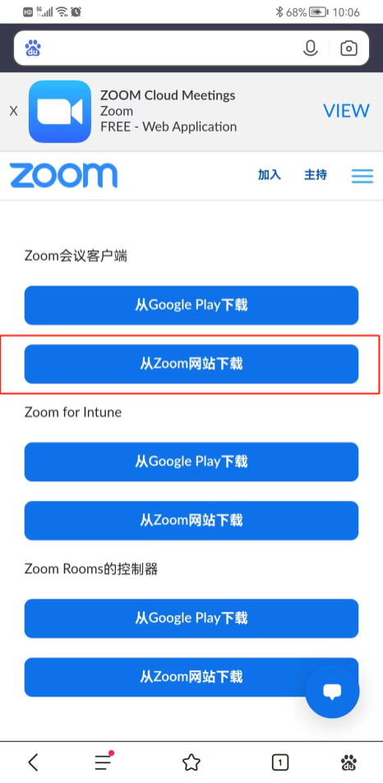
ZOOM软件下载
1. 电脑版
进入https://zoom.us/download，下载Zoom桌面客户端
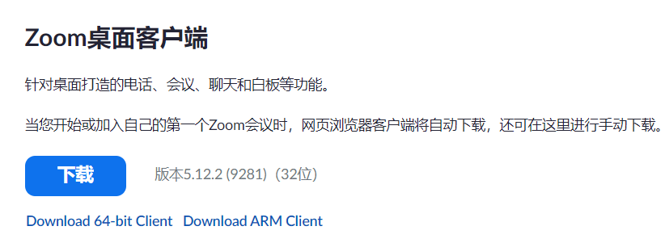
2. 苹果手机
直接从App Store下载

3. 其他手机
复制https://zoom.us/download到手机浏览器，选择
“Zoom会议客户端”，“从Zoom网站下载”即可。

